Project Design Phase-II
Technology Stack (Architecture & Stack)

Date | 26 June 2025
Team ID | LTVIP2025TMID59612
Project Name | SB Foods - On-Demand Food Ordering Platform
Maximum Marks | 4 Marks

Technical Architecture Overview:
The SB Foods system is built using a 3-tier architecture:
- Frontend (Presentation Layer) using React.js
- Backend (Application Logic Layer) using Node.js + Express.js
- Database Layer using MongoDB (NoSQL)
This ensures separation of concerns, easy scaling, and maintainability.

Example: Order processing during pandemics for offline mode
Reference: https://developer.ibm.com/patterns/ai-powered-backend-system-for-order-processing-during-pandemics/

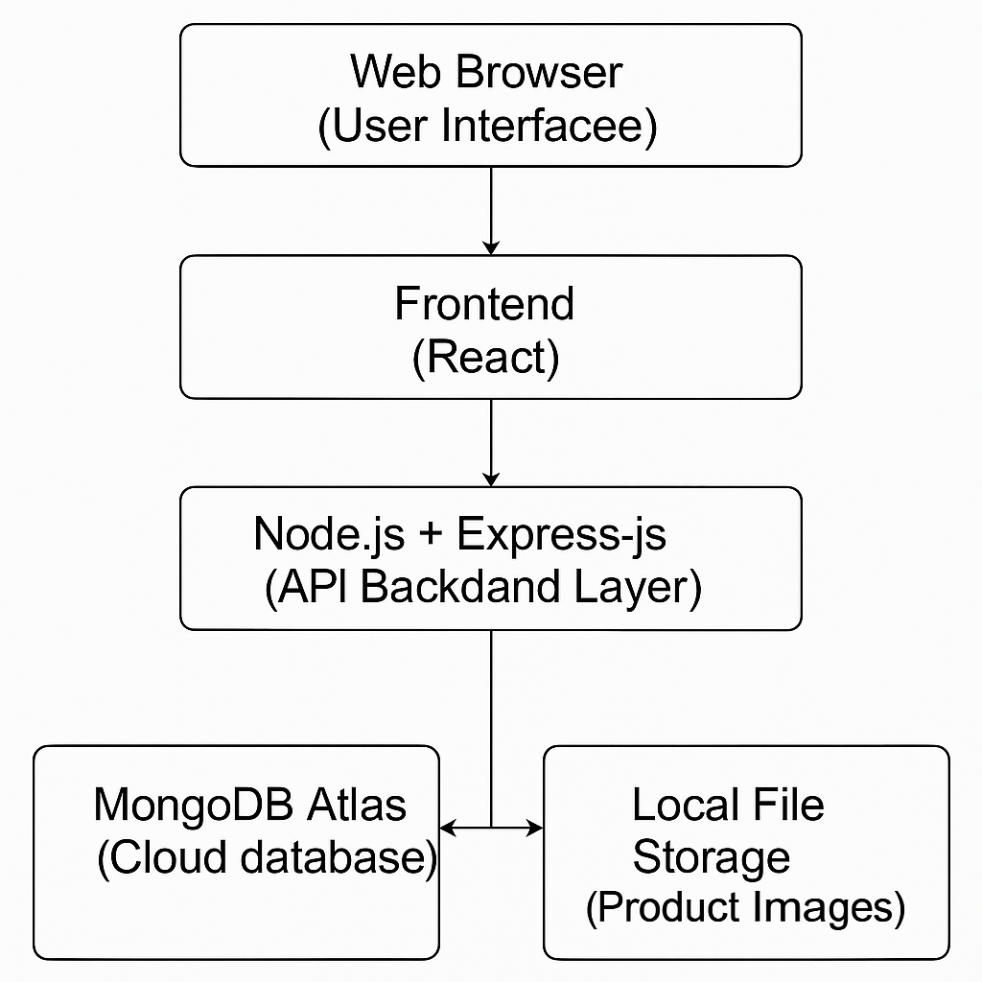

Table-1 : Components & Technologies:
S.No | Component | Description | Technology
1 | User Interface | Web UI accessible via desktop/mobile | React.js, HTML, CSS, JavaScript
2 | Application Logic-1 | Handles product listing, ordering, user flows | Node.js, Express.js
3 | Application Logic-2 | OTP/Email Confirmation Service | Nodemailer / Twilio APIs
4 | Application Logic-3 | Admin Dashboard logic, CRUD operations | Express.js
5 | Database | NoSQL database for products, orders, users, etc. | MongoDB
6 | Cloud Database | Cloud-hosted DB instance | MongoDB Atlas
7 | File Storage | Product images and static files | Local FileSystem / Cloudinary
8 | External API-1 | Pincode validation / address autocomplete | India Post API / Google Maps API
9 | External API-2 | Payment integration | Razorpay / Stripe
10 | Machine Learning Model | (Optional/Future) Personalized food recommendations | TensorFlow.js / Scikit-learn (TBD)
11 | Infrastructure | Deployment configuration | Local server / Vercel / Railway.app

Table-2: Application Characteristics:
S.No | Characteristics | Description | Technology / Approach
1 | Open-Source Frameworks | Frameworks used in development | React.js, Node.js, Express, MongoDB
2 | Security Implementations | Password hashing, secure login, CORS, data validation, rate limiting | bcrypt.js, Helmet, HTTPS, JWT, SHA-256
3 | Scalable Architecture | 3-tier, microservice-ready backend, separation of concerns | Express Router, Modular Folder Structure
4 | Availability | 99.9% uptime, hosted on cloud, ready for scaling | Vercel / Railway / MongoDB Atlas
5 | Performance | Fast API response, CDN for images, lazy loading, caching, pagination | React lazy, MongoDB indexing, Redis (optional)

References:
https://c4model.com/
https://developer.ibm.com/patterns/online-order-processing-system-during-pandemic/
https://www.ibm.com/cloud/architecture
https://aws.amazon.com/architecture
https://medium.com/the-internal-startup/how-to-draw-useful-technical-architecture-diagrams-2d20c9fda90d

